|  |
| --- |
| Term Project  Nitro Drills |

|  |
| --- |
| Asif Mahmud  ID - C0837117  Product- Drills |

|  |  |
| --- | --- |
| Database Design & SQL  Faculty – Jim Cooper  Term – Fall |  |

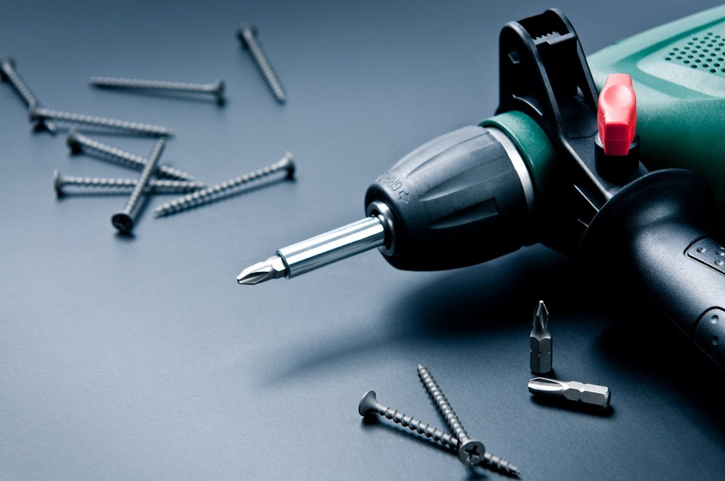

Contents

Company Description2

1.1 Company Name2

1.2 Company Overview2  
1.3 Product3  
1.4 Product Attribute3

Customer Sale Invoice4

2.1 Invoice4

Entity Relationship Diagrams5

[3.1 ER Diagram (With M:M)5](#_ER_Diagram_(With)

[3.2 ER Diagram (Without M:M)6](#_ER_Diagram_(Without)

|  |
| --- |
| Company Description |

|  |
| --- |
| Company Name:  Nitro Drills Company Overview: Nitro Drills was establish in 2016 with the goal to deliver tools necessary in several works maintaining the quality, durability and lowest price possible to the customers. At first we were named ‘Nitro Tools’. But then as the sales growth in drills were much more than other products, we focused on just only one product to deliver the best drills possible to our customers.   Now we are known as one of the best drills seller in the country. We have drills of the best price range and functionality and our drills are particularly known for durability. We have several brands in our collection. We focus on customer satisfaction more than anything. We believe that customers are always right. |
| Product:  Drills Product Attribute:  |  |  | | --- | --- | | **Attributes** | **Sample Data** | | Product Id (UK) | 12345 | | Model Number | 58736 | | Product Name | Black & Decker Electronic Drill | | Assembly Required | No | | Batteries Required | Yes | | Batteries Included | Yes | | Manufacturer | JAKKS Pacific | | Stock | 100 | | Product Dimension | 5.08 x 21.29 x 24.13 cm; | | Weight | 900 gm | | Color | Yellow | | Warranty | 2 Years | |

|  |
| --- |
| Company Description |

## Invoice:

|  |
| --- |
| Customer Sale Invoice |

## ER Diagram (With M:M):

|  |
| --- |
| Entity Relationship Diagrams |

## ER Diagram (Without M:M):

|  |
| --- |
| Entity Relationship Diagrams |